 | ASIA-PACIFIC TELECOMMUNITY | Document No:
 | The 6th Meeting of the APT Conference Preparatory Group for WRC-23 (APG23-6) | APG23-6/INF-xx
 | 14 – 19 August 2023, Brisbane, Australia | xx August 2023

GSA

views on IMT-2030 (6G) spectrum

- Introduction

IMT-2030/6G is expected to become the primary mobile technology in the 2030s and will offer an enhanced user experience compared to previous generations. 6G promises ultra-fast data rates with lower latency, significant energy efficiency, and greater reliability besides sensing connectivity, immersive communications and communications empowered by artificial intelligence.
ITU-R Working Party 5D has developed a work plan, timeline, process and all the required deliverables for the future development of IMT that are necessary to be provided by the 2030 timeframe. The process and related deliverables were agreed as shown in Figure 1 as an overview.
FIGURE 1
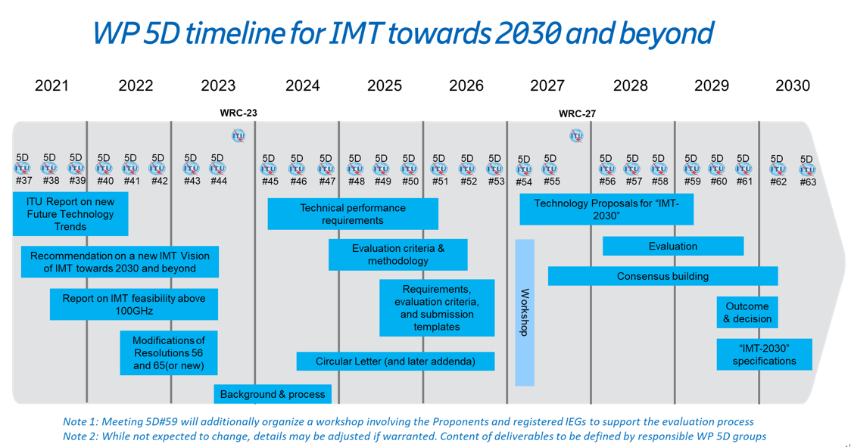

In accordance with this timeline, WP5D has finalized and agreed a Draft New Recommendation, “Framework and overall objectives of the future development of IMT for 2030 and beyond” in its June meeting of 2023. The publication of the Framework Recommendation is expected to communicate the overall objectives of IMT-2030 to research organizations and standardization bodies around the world, thus helping them to focus their activities towards common goals. In addition, WP 5D has also completed a new ITU-R Report on “Future Technology Trends”, which has been published as ITU-R Report M.2516​ in December 2022. This Report has provided an overview of future technical aspects of terrestrial IMT systems considering the timeframe up to 2030 and beyond. All these relevant information can be found from the ITU-R IMT-2030 website (https://www.itu.int/en/ITU-R/study-groups/rsg5/rwp5d/imt-2030/Pages/default.aspx).
Meanwhile, spectrum remains a critical enabler and spectrum discussions have already started in global, regional and national groups. APG is invited to consider the need for a WRC-27 agenda item to address the additional spectrum needs of IMT-2030/6G.

- Proposal
APG is invited to consider GSA’s views on IMT-2030(6G) spectrum needs and candidate bands described in the annex in relation to addressing a WRC-27 agenda item for IMT.

ANNEX

IMT-2030 / 6G Spectrum Needs and Candidate Bands

- Introduction
This contribution provides GSA’s analysis on the spectrum needs relevant for IMT-2030/6G. In addition, a list of bands is proposed in order to initiate a discussion on potential bands to be studied, as part of a new agenda item for IMT at WRC-27.
3G
IMT- 2000
IMT- Advanced
IMT- 2020
IMT- 2030
4G
5G
6G

The evolution of the mobile technology is aligned with the development in ITU and it is important that WRC-27 identifies additional frequency bands for IMT to deliver the full potential of IMT-2030/6G.
It is to be noted that similar to the previous cellular generations, one essential component for the success of IMT-2030/6G is the possibility to provide wide contiguous coverage, servicing both indoor and outdoor users and enabling mobility. From this perspective, looking for suitable spectrum range(s) to accommodate future growth is essential.

- Spectrum needs
In one GSA document on IMT-2030 (6G) spectrum needs analysis, submitted as APG23-5/INF-26 in February 2023 to the 5th Meeting of the APT Conference Preparatory, use cases such as XR, holographic communications, and integrated sensing and communication were highlighted as drivers for additional wide-area spectrum in the 6G timeframe.
The analysis is based on assessment methods that are straight-forward, and not over-complicated technically and creates a link between the most relevant use cases and their spectrum implications/needs.
According to the analysis, the estimated additional wide-area spectrum need per network would be ~500 to ~750 MHz depending on the existing mid bands spectrum available for IMT and on the number of networks in a specific country.
If assuming typically 3-4 networks in a country, and that in the long term, existing mid bands spectrum will be re-used for IMT-2030/6G wide area use cases, the overall additional spectrum needs will approximately be 2 to 3 GHz for the analyzed wide-area use cases (corresponding respectively to the cases of 3 and 4 operators in a country).
In order to close this gap/shortfall, suitable spectrum must be considered in the closest proximity to mid-bands. This is where the 7.125–15.35 GHz range enters the picture, noting that there are propagation differences within this range, the closer to the mid-band range (below 7 GHz), the greater the possibility of reusing the existing base station grids and the lower the number of required new sites, costs, and power consumption for the delivery of services.
The additional spectrum from within the 7.125–15.35 GHz range is necessary to realize the capacity-demanding use cases in future 6G networks and is key to enabling mobility for many of these use cases. Any mobility and coverage restrictions would deprive such use cases of their full potential and value to society. It is also the ultimate goal to achieve global harmonization of frequency bands for IMT in order to achieve homogenous ecosystem and reap the benefits of economies of scale.

To realize the future network vision enabled by IMT-2030/6G and to deliver its full potential, there is a need to secure timely spectrum availability. Given the time it takes to secure additional spectrum through regulatory deliberations in ITU and/or regional groups and to avoid delaying initial IMT-2030/6G commercial deployments starting around 2030, it is now the time to start the process to ensure timely availability of IMT-2030/6G spectrum. APG is thus invited to consider the need for a WRC-27 agenda item to address the additional spectrum needs of IMT-2030/6G.

- Candidate bands
GSA supports a new agenda item for IMT at WRC-27, with a focus on the following bands:

- 7.125-8.5 GHz
- 10.7-11.7 GHz
- 11.7-12.75 GHz
- 12.75-13.25 GHz
- 14-14.8 GHz
- 14.8-15.35 GHz

This list of bands is proposed in order to initiate a discussion on potential bands to be studied for WRC-27 noting that some (or parts) of the above bands may not be considered to be studied for IMT in some countries and regions.

For some of the bands listed above, some GSA members also have interests in other wireless technologies / applications.

